Hello Hawthorne Families,

I am sending along costume ideas for our big performance coming up on April 29th!... Please look at the following word document attachment with all of the suggestions for your child’s performance.

If you need any help with costumes please sign up on the link below and let us know what we can help with:

[https://www.signupgenius.com/go/10C0F4FAEA829A5FCC07-48531955-little](https://nam12.safelinks.protection.outlook.com/?url=https%3A%2F%2Fwww.signupgenius.com%2Fgo%2F10C0F4FAEA829A5FCC07-48531955-little&data=05%7C02%7Cemwise%40seattleschools.org%7C6c6331620c9443eb5d3608dc482f7644%7Cd431d15860744832878351ea6f6dd227%7C0%7C0%7C638464615893910439%7CUnknown%7CTWFpbGZsb3d8eyJWIjoiMC4wLjAwMDAiLCJQIjoiV2luMzIiLCJBTiI6Ik1haWwiLCJXVCI6Mn0%3D%7C0%7C%7C%7C&sdata=bjtI3a%2BLy7359nbKJG9Mbc9tM4%2BO%2BK6KFCpRe4wwHWE%3D&reserved=0)

With any other questions please email me at:

**Emwise@seattleschools.org**

COSTUME IDEAS FOR MUSIC PERFORMANCE:

K/1: Bright fun ocean colors…happy fish types such as mermaid/Merperson, crab, flounder, seaguls

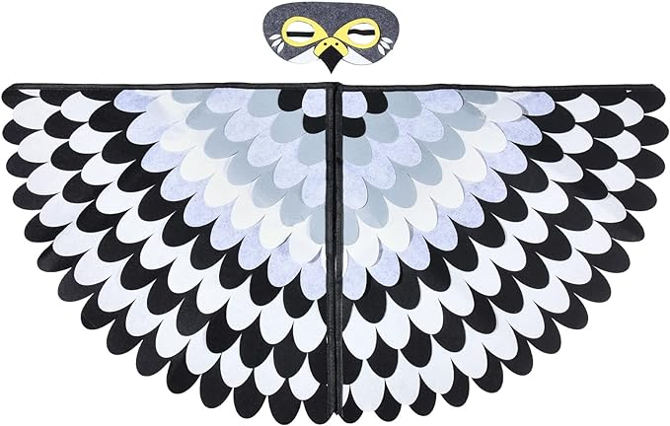

2nd: Dark/Neon ocean colors…dark ocean creatures such as octopi, eels, angler fish, sharks…

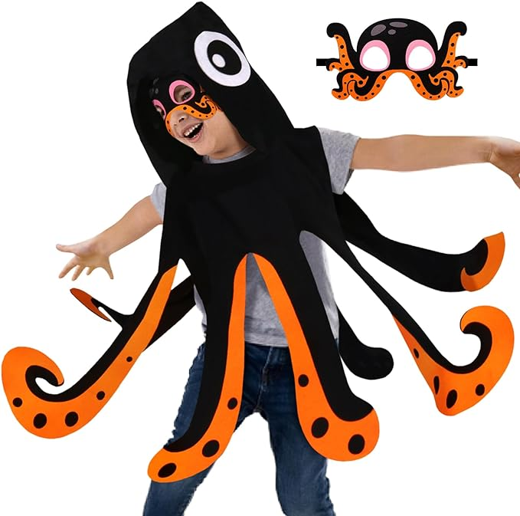 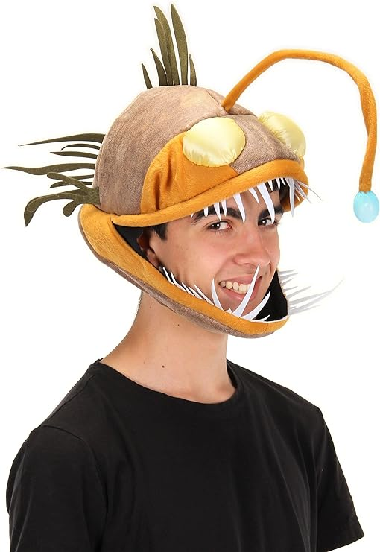 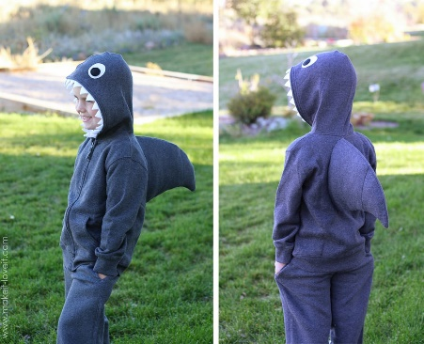 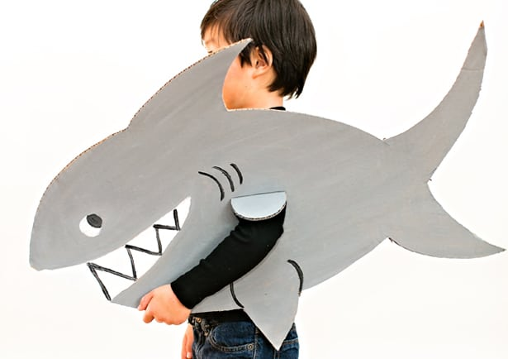

3rd: Chefs, lobster or Crab :

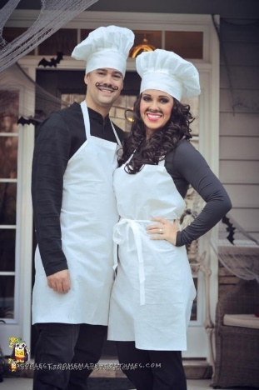

4th: Bright fun Ocean colors and ocean animals, mermaid/merperson or Sea Kelp:

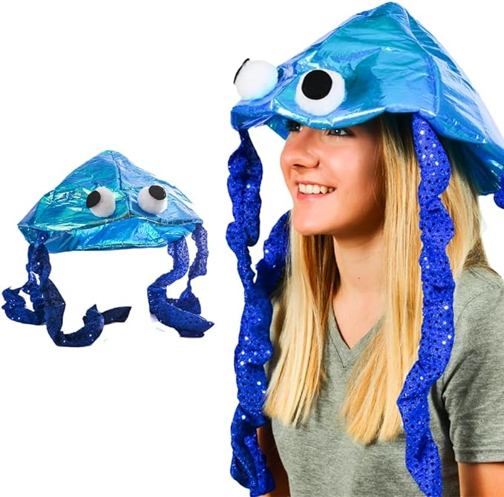 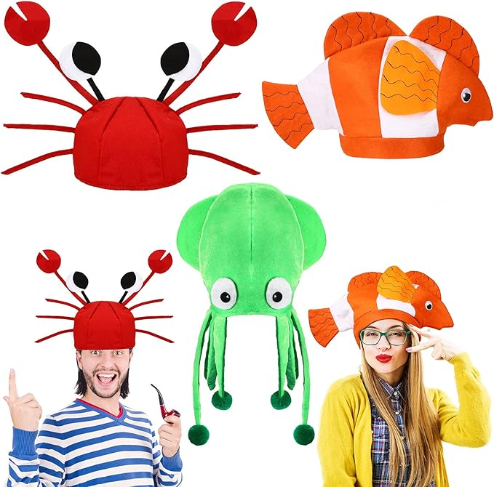

5th: Sailor (think more like Pirates of Caribbean) look:

